Lab #4
Math for Microprocessors: ALU and FPU

Purpose:
This lab is a two part ASM and VHDL lab. Part 1 will have you design a 32 bit ALU leveraging your work from Lab #3. Part 2 will have you dive deeper into integer and floating point math in MIPS assembly.

Preparation:
Review class presentations and Chap 3 + Chap 4 from the text.

Procedure:

Part 1 -

You will design and implement a 32bit ALU. Your ALU will use the shift register and adder/subtracter from Lab #3.

The ALU interface will have the following entity definition:

entity ALU is
Port( DataIn1: in std_logic_vector(31 downto 0);
DataIn2: in std_logic_vector(31 downto 0);
Control: in std_logic_vector(4 downto 0);
Zero: out std_logic;
ALUResult: out std_logic_vector(31 downto 0));
end entity ALU;

Your ALU will need to support the following MIPS instructions:

add
sub
addi
and
or
ori
sll
srl

Note that the 32 bit data for the add, sub, and, & or instructions will come from DataIn1 and DataIn2. The immediate data for addi, ori, sll and srl instructions will come from DataIn2 (just like is shown in Figure 4.15, there is a mux outside of the ALU that will route either a data register or the lower 16 bits of the MIPS instruction (sign extended) to your ALU DataIn2 port). Note the location of the shamt value bits on DataIn2 will match those of the R-type instruction.

The ALU circuit design will look like this:

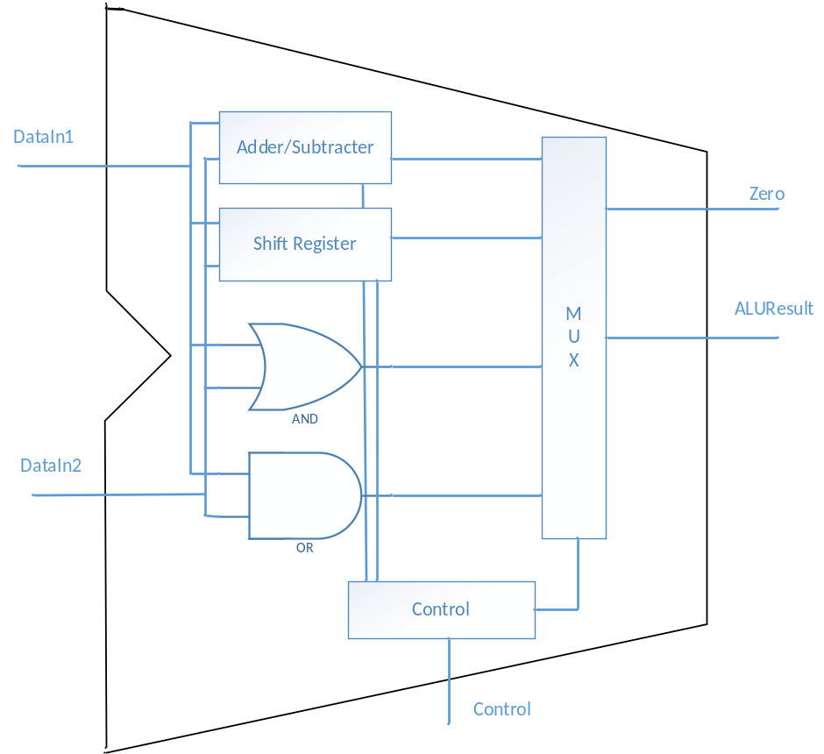

You will develop the ALU as well as a test bench to exercise your design.

Note that the ALU presented in the textbook was a simplified version of the full ALU that supports the entire MIPS instruction set. Figures 4.12 and 4.13 will help you start the design of your ALU Control input, but whereas the text’s ALU has only 4 control lines, your ALU has 5. You will need to create a truth table like Figure 4.12 to support all the MIPS instructions listed above.

The Zero output is 1 if the ALUResult is equal to zero, and 0 otherwise.

The shift register from Lab #3 had a maximum shamt of 3 bits, and that restriction also applies here.

Part 2 –

For each program, create a separate asm file. For your lab report, describe how you implemented your program. Indicate which registers or memory addresses were used for variables. Include screenshots of QtSpim before and after your program runs. Describe how you know each program is functioning correctly. Submit your lab report and all source files to Canvas to get full credit.

- Create a program to read a float (single precision) value for degrees Fahrenheit from the user and convert the temperature to Celsius and Kelvin using the following formula:

Celsius = (Fahrenheit – 32.0) x 5.0 / 9.0
Kelvin = Celsius + 273.15

Output the results of the conversions to the user. The temperature conversion formula needs to be implemented as a function call.

- Create a program that calculates a Fibonacci number. Implement this code from C

int main()
{
int a, b, c;

a = Fibonacci( 3 );
b = Fibonacci( 10 );
c = Fibonacci( 20 );
}

int Fibonacci( int n )
{
int value;

if( n <= 0 )
value = 0;
else if( n == 1 )
value = 1;
else
value = Fibonacci( n - 1) + Fibonacci( n – 2 );

return value;
}

The first 10 Fibonacci numbers (starting with index 0) are 0, 1, 1, 2, 3, 5, 8, 13, 21, 34, 55

- Create a program that exercises each of the following MIPS instructions that your ALU design supports:

add
sub
addi
and
or
sll
srl

The code you use in this program needs to also match what you are using for your VHDL test bench. You can use the results of this program to check the accuracy of your ALU implementation.

Lab Report:

You will submit on Canvas a Word document containing your report and text files containing your final, working VHDL and ASM source code. Your report will have the following sections.
- Cover Page with lab title and your name.
- A brief description of the design
- Truth table for your ALU Control input decoding
- A description of how you tested your ALU design and your ASM code
- Is there a limit on the Fibonacci number your program can calculate? Why or why not?

Files to be submitted:

Lab report
VHDL source code for the ALU and the ALU test bench
ASM source code for the programs
Proof that your ASM programs are functional

